**Module 7: Assignment 1: Server-side rendering**

Saurabh Verma

Arizona State University

IFT 598: Middleware Programming & Database Security

Professor. Dinesh Sthapit

November 12, 2022

**Assignment: Using Server-Side Rendering with PUG Server.**

Adding loanController.js to the project:

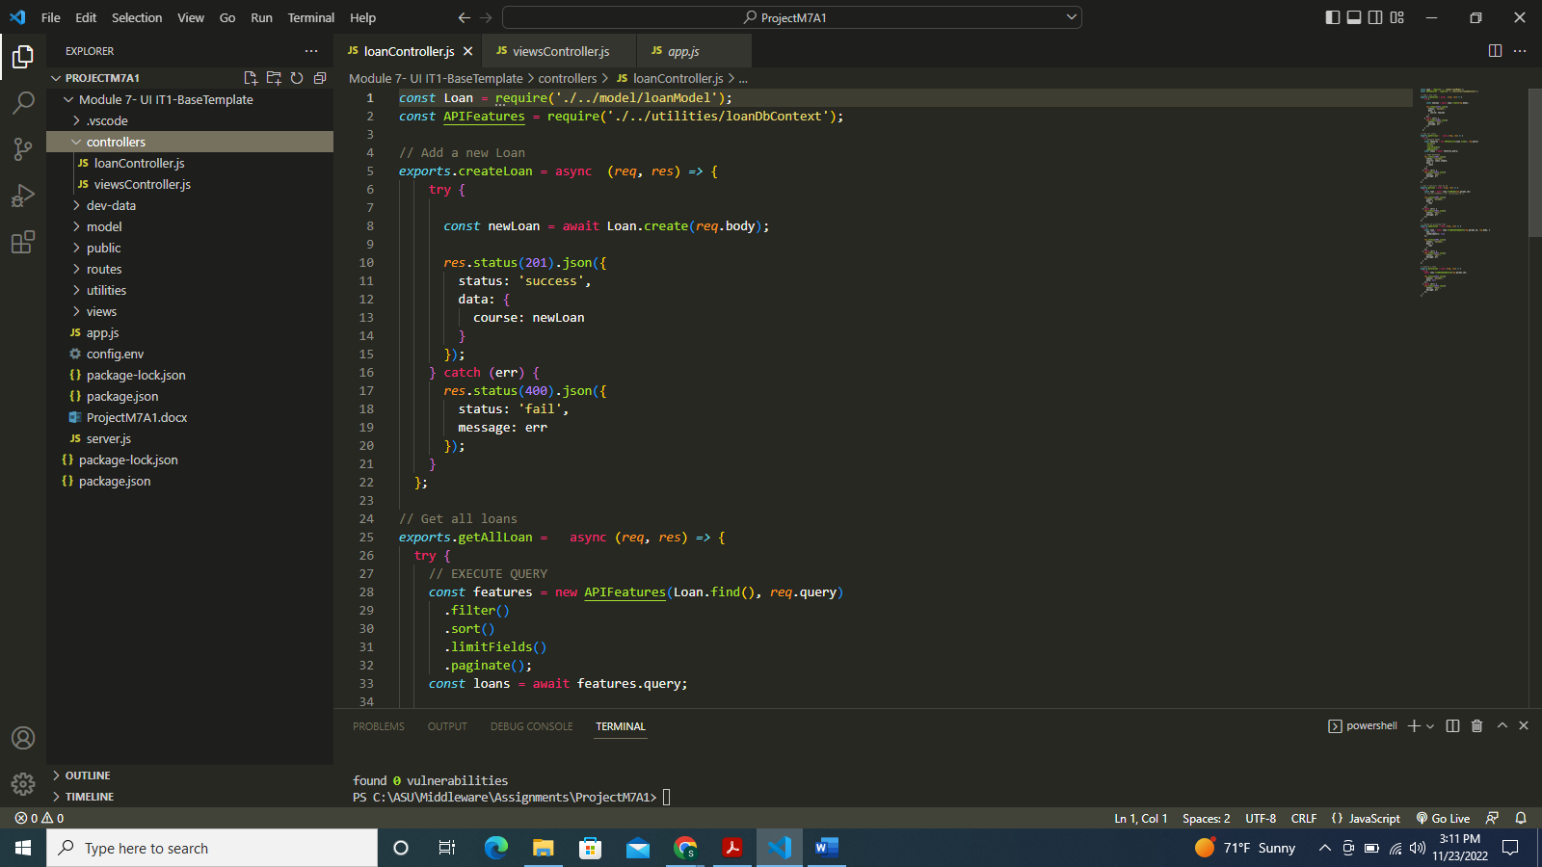

Adding loanModel.js in model folder of the project:

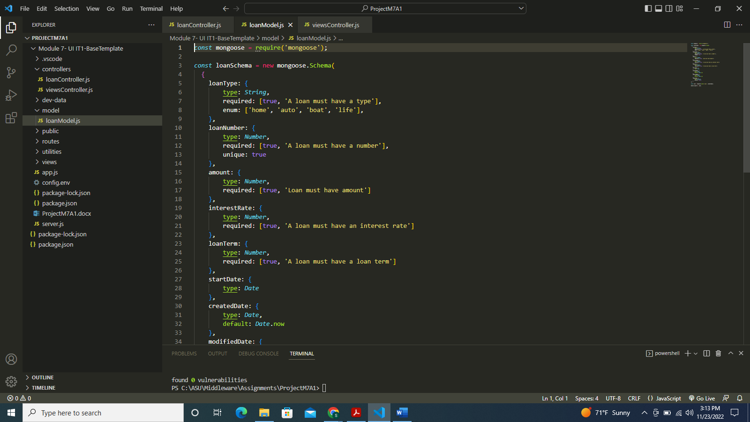

Adding loanRoutes.js to the routes folder in the project:

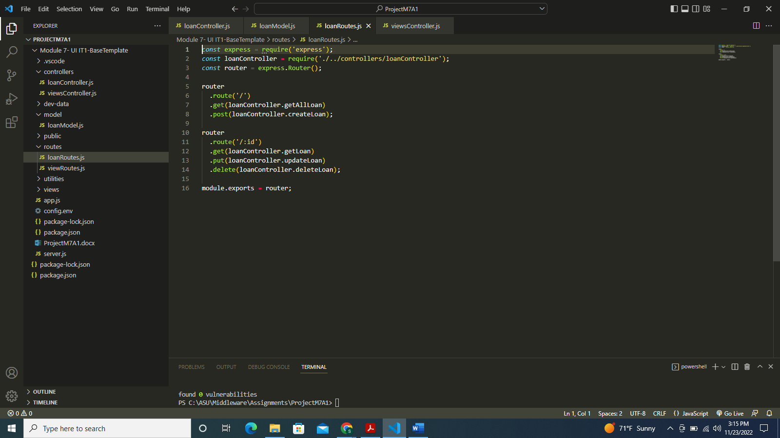

Adding getLoan for adding loanList functionality to the viewsController:

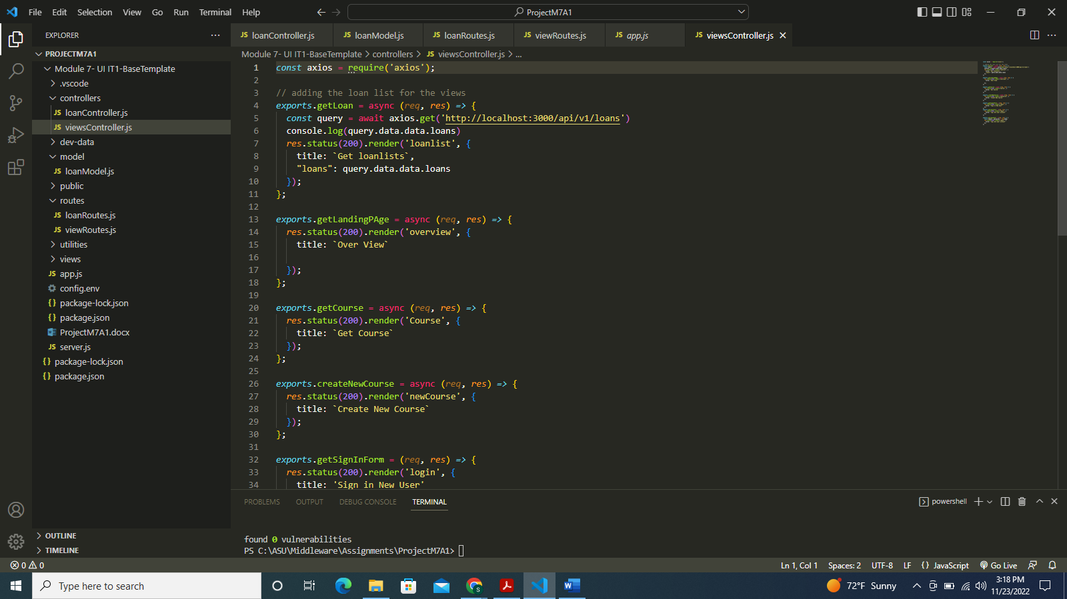

Adding the loan route in app.js:

Updating the viewRoutes by adding the loanList:

Adding loanList.html in public folder:

Adding loanList.pug file in the views folder:

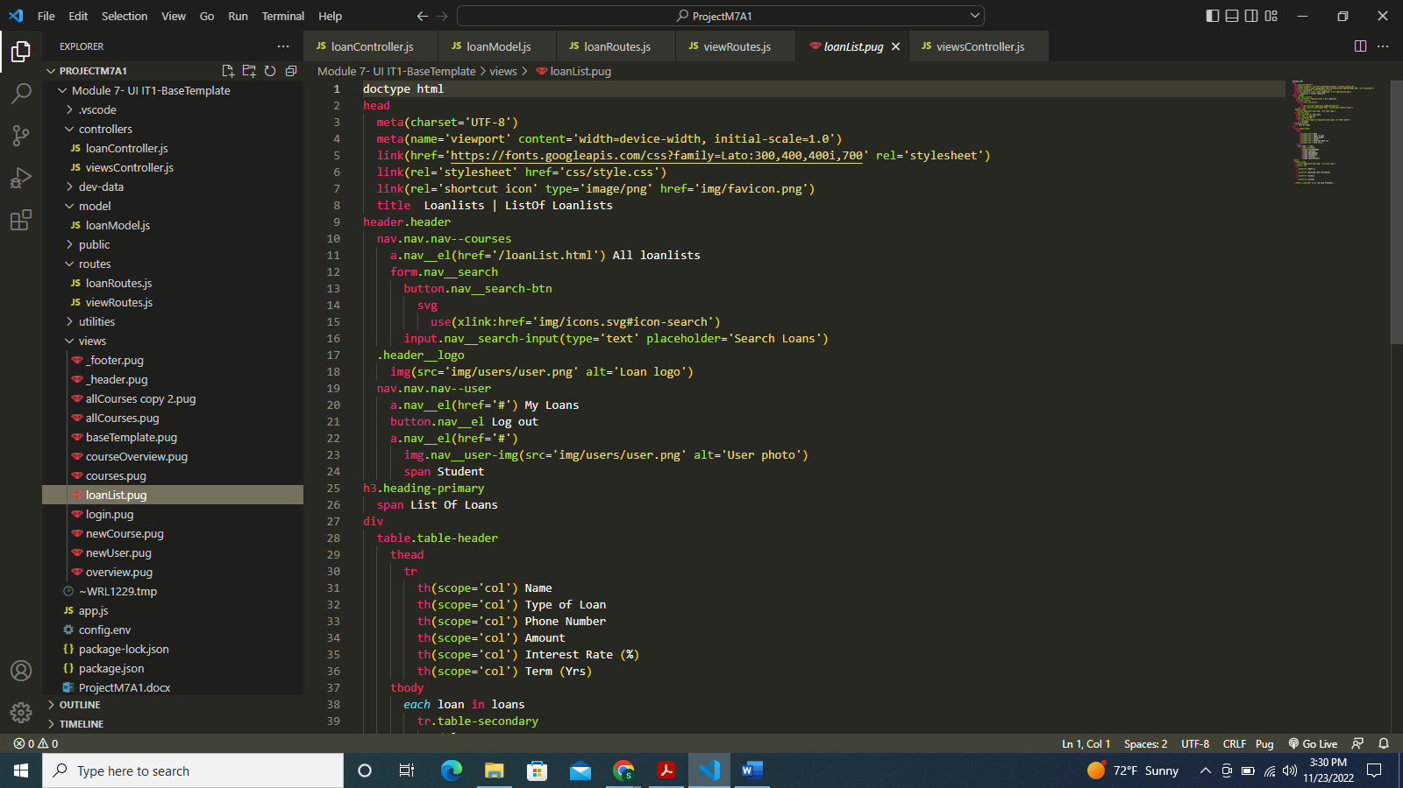

Changing the config.env as per the project:

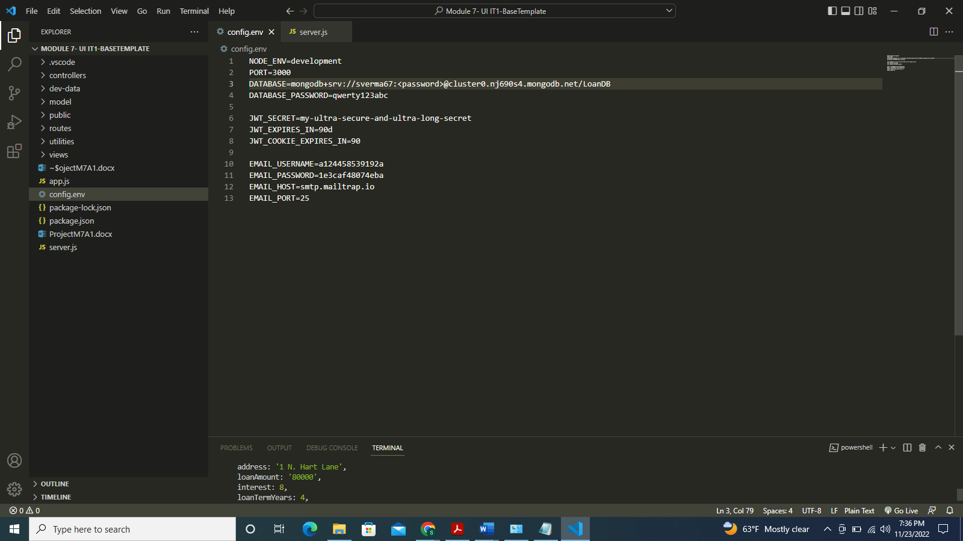

Updating server.js file by adding mongoose connection:

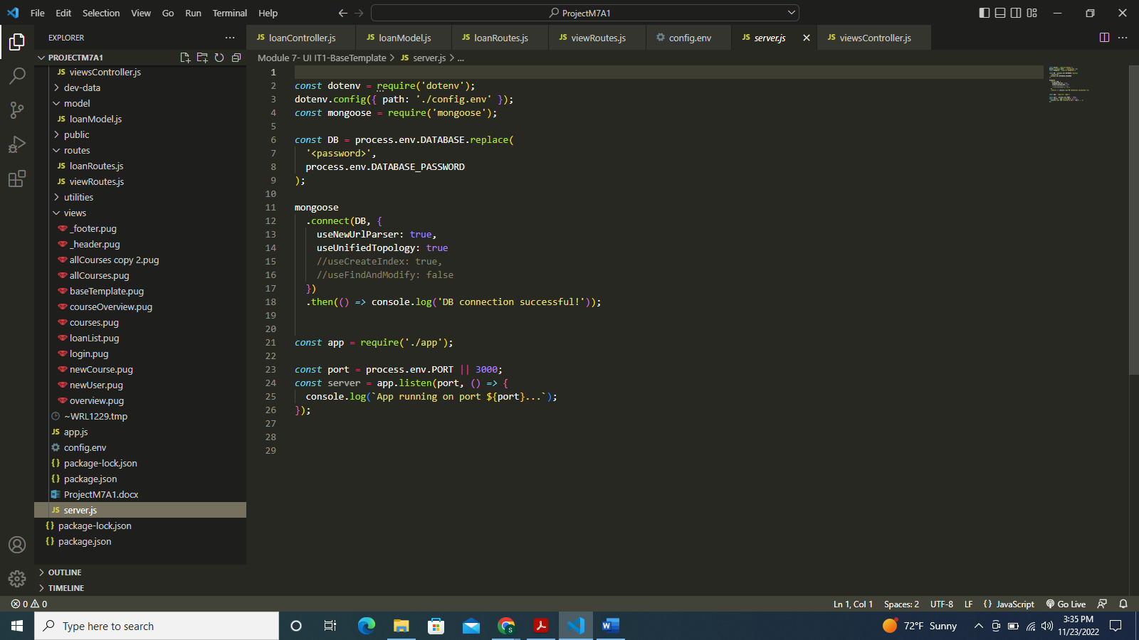

Executing the code, connecting to the database:

Executing the code, connecting to frontend, running localhost:3000/api/v1/loans to fetch the loan list:

Executing the code, connecting to frontend, running localhost:3000/loanList to fetch the loan list using PUG file:

**References**

GitHub repository:

[Additional resource](https://docs.google.com/presentation/d/1ht8VPSqnoT_69I5laE23tAl6xU5F44he/edit#slide=id.p1)

[VSCode tutorial](https://www.youtube.com/watch?v=ZfCi0Is9gLU)